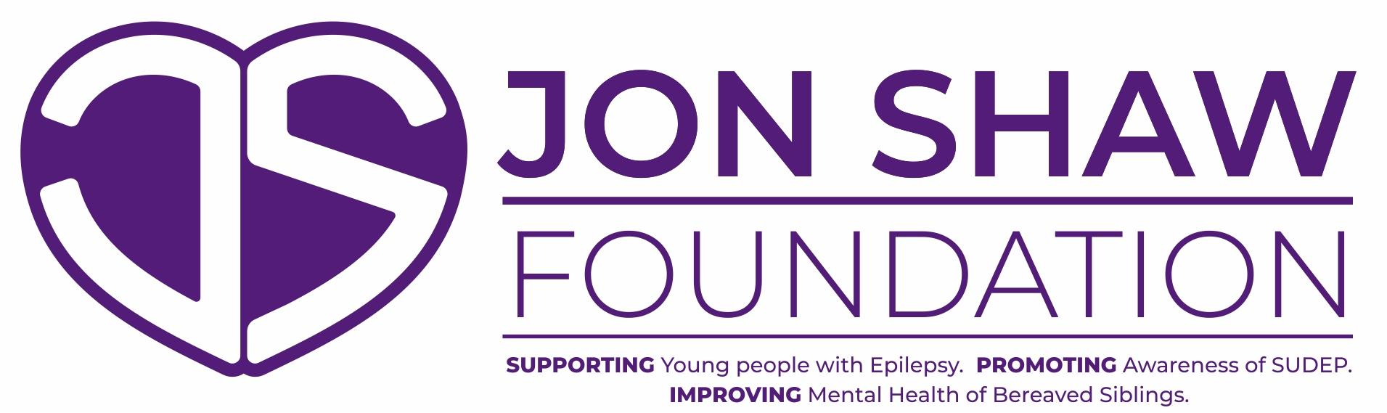
As a new charity we are learning how best to help others, your feedback will help with this process. Funds and equipment are very limited at this time so we would ask that you help us to build our resources by agreeing to the following;-
- I the undersigned confirm that I have received the equipment I requested. I understand that this remains the property of Jon Shaw Foundation. If after a trial period of 30 days the unit has proven to be unsuitable for our needs I agree to return it to Jon Shaw Foundation in pristine condition. If after the trial period the unit is helping to manage nocturnal epileptic seizures we will continue to use the unit as part of our care plan for as long as it is needed.
- I give permission for my image and story to be used in publicity events and on the Foundation Social Media.
- I further agree that I will provide feedback when requested and a written testimonial which will be used by the Foundation as part of an impact statement for the Charities Commission.
- I agree that I will either offer a contribution (amount to be discussed) towards the equipment and / or support Jon Shaw Foundation by organising a Fundraising Event, enabling us to continue to help other families. We are happy to support Fundraising events.

Name ----------------------------------------

Signature ------------------------------------------ Date ---------------------------------
Any promotion and positive statements on social media will help Jon Shaw Foundation grow and thank you for those. If there is anything which has upset or concerned you about our charity, please share it with one of the Trustees and we will do everything we can to resolve the issue.

